Responsible and Open Science Citizenship

Responsible Conduct of Research

Responsible conduct of research consists of a number of different areas of action. Within these different areas, scientists operate in multiple roles with multiple responsibilities.

- Data producer
- Data user and/or collaborator
- Author
- Employee
- Teacher/mentor
- Recipient of public funds
- Recipient of public trust
- Citizen/legally-obligated individual

RCR, Open Science and Ethical Norms

Practice of scientific investigation with integrity. To enact integrity through open practices

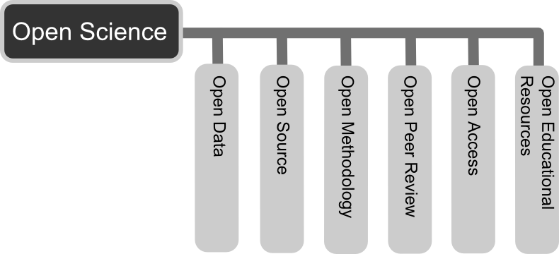
Open science has many tools through which you can realise your responsible and open science citizenship. These tools directly relate to the key norms underpinning science citizenship.

- Beneficence – to ensure that research has the maximal benefits for the most number of people
  - To engage in research that has demonstrable public good, to share research outputs both within and beyond the academic community to ensure that it is maximally reused
- Non-maleficence
  - To scrutinize all research undertakings for instances that can cause harm. This includes research misconduct as well as unintended harms (ie. introducing biases in algorithms or sharing data that could be used to harm a group of individuals)
- Accountability and transparency
  - To take responsibility for all your research undertakings and be able to report procedures to funders, peers and academic community (ie. RDM and DMP)
  - To be willing to engage in the maximal amount of open activities to enable research to be scrutinized (ie. using author tools)
- Collegiality – the responsibility to uphold and enhance the scientific community and its activities
  - Through resource sharing, mentorship, service (ie. peer review, contributing to user communities, voluntary activities)
- Justice – fair distribution of scientific resources
  - Scrutinizing databases, sharing platforms and practices of sharing to ensure that no groups of potential users are unintentionally marginalized

