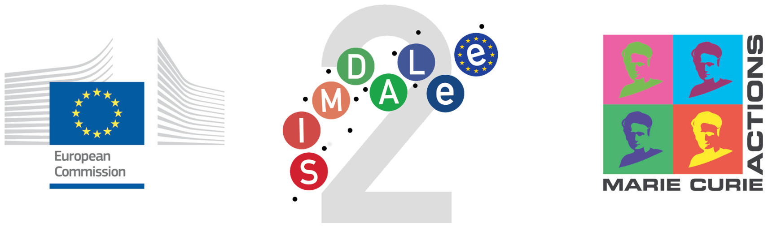
5th-7th PROGRESS MEETING & Workshop
SIMDALEE2 – Marie Curie Initial Training Network
19th September 2016 – 22nd September 2016
Organized by
A.P.E.Research srl - Area Science Park, Trieste
and
Jožef Stefan Institute - Jamova cesta 39, 1000 Ljubljana

Participants list

1 | Mr. Wolfgang Werner | Vienna University of Technology
2 | Mr. Ernst D. Janotka | Vienna University of Technology
3 | Ms. Maria Steiner | Vienna University of Technology
4 | Mr. Vytautas Astašauskas | Vienna University of Technology
5 | Mr. Pavel Kuksa | Vienna University of Technology
6 | Mr. Ashish Suri | University of York
7 | Mr. Chris Walker | University of York
8 | Mr. Steve Tear | University of York
9 | Mr. Stefano Prato | APE Research S.r.l.
10 | Mr. Stefano De Monte | APE Research S.r.l.
11 | Ms. Ana Varlec | APE Research S.r.l.
12 | Ms. Ilona Müllerová | Academy of Sciences of the Czech Republic
13 | Mr. Benjamin Daniel | Academy of Sciences of the Czech Republic
14 | Mr. Danilo Pescia | ETH Zürich
15 | Mr. Gabriele Bertolini | ETH Zürich
16 | Mr. Oguzhan Gürlü | ETH Zürich
17 | Mr. Seyno Sluyterman | FEI Electron Optics
18 | Ms. Alessandra Belissimo | University of Roma Tre
19 | Mr. Stefan Voss | RoentDek Handels GmbH
20 | Mr. John Xanthakis | National Technical University of Athens
21 | Mr. Andreas Chatziafratis | National Technical University of Athens
22 | Mr. Fengshan Zheng | Forschungszentrum Jülich
23 | Ms. Maja Remškar | Jožef Stefan Institute
24 | Mr. Muhammad Saqib | Jožef Stefan Institute
25 | Mr. Chris Edgcombe | University of Cambridge
26 | Ms. Sabrina Masur | University of Cambridge
27 | Ms. Barbara Troian | APE Research S.r.l.
28 | Mr. Damiano Cassese | APE Research S.r.l.

