Instructions on how to obtain GNSS TEC from the Madrigal Database (http://cedar.openmadrigal.org/)

Currently we produce vertical total electron content maps from approximately 6000 GNSS dual-frequency receivers world-wide. TEC data is stored in 1 deg by 1 deg bins at a 5 minute cadence and produce global TEC maps at a 20 minute cadence in bins of 3 deg by 3 deg. This TEC data is available on line from 2000 on.

A new product – the line of sight TEC data – is available for the last 3 years. These data files are extremely large, typically over a gigabyte per day. They provide TEC for every receiver, every 30 seconds (time), for every receiver and every satellite. The files are in HDF5 format.

To obtain both types of data ( the gridded gps and los files), go to a madrigal website.

http://cedar.openmadrigal.org

You may have to register your name and institution.

Then - from the main page select : Access Data

A list will appear – hit select single experiment to start.
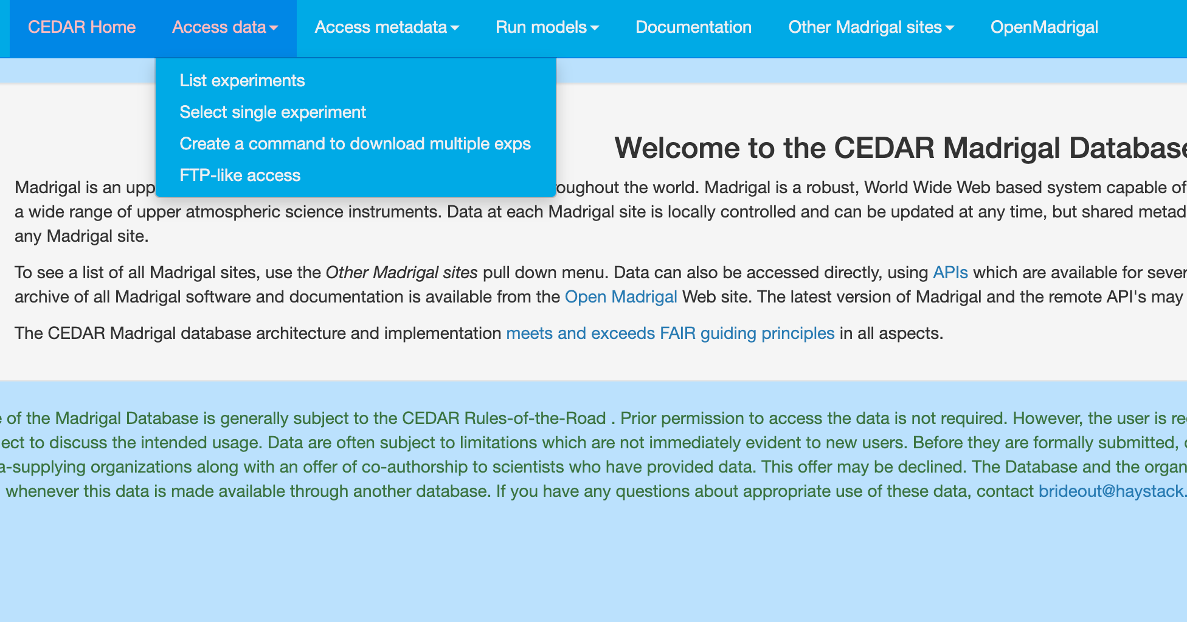

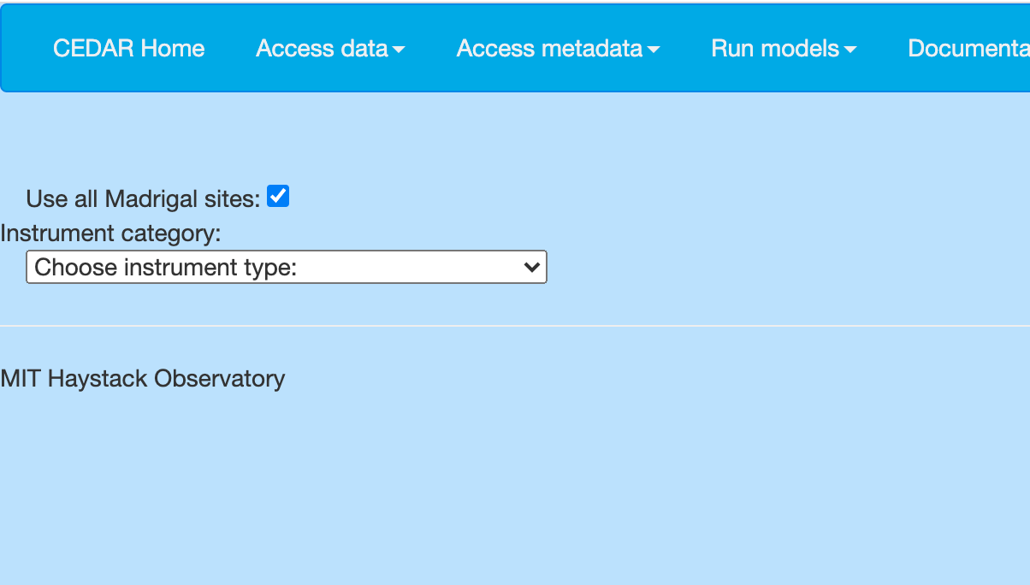

FOR: instrument category

distributed ground based satellite receivers

FOR: choose instruments

world-wide gnss receiver network (1998-2019)

THEN fill in start and stop dates and times

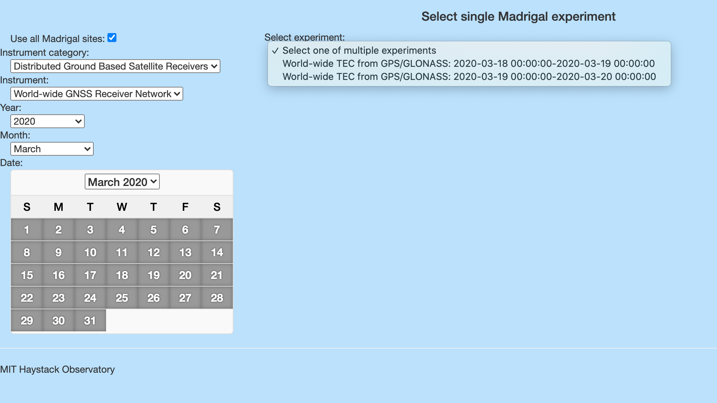

there will be one or two data files available in hdf5 format.

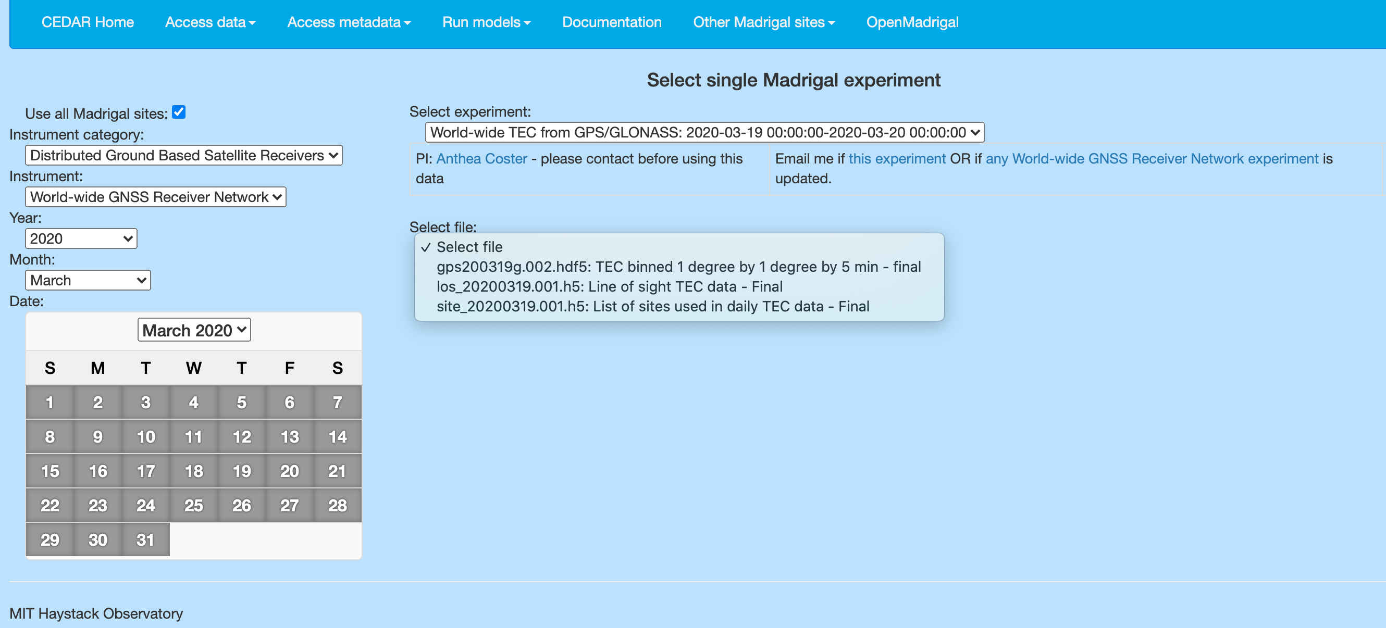
The gps files are the 1 degree by 1 degree binned TEC files every 5 minutes

The los files are larger and are the line of sight files.

The site files show you what sites were used to compute the los and gps files.

If you select either of these files – you should have the availability to look at our plots or our TEC maps when you hit the button called show plots.
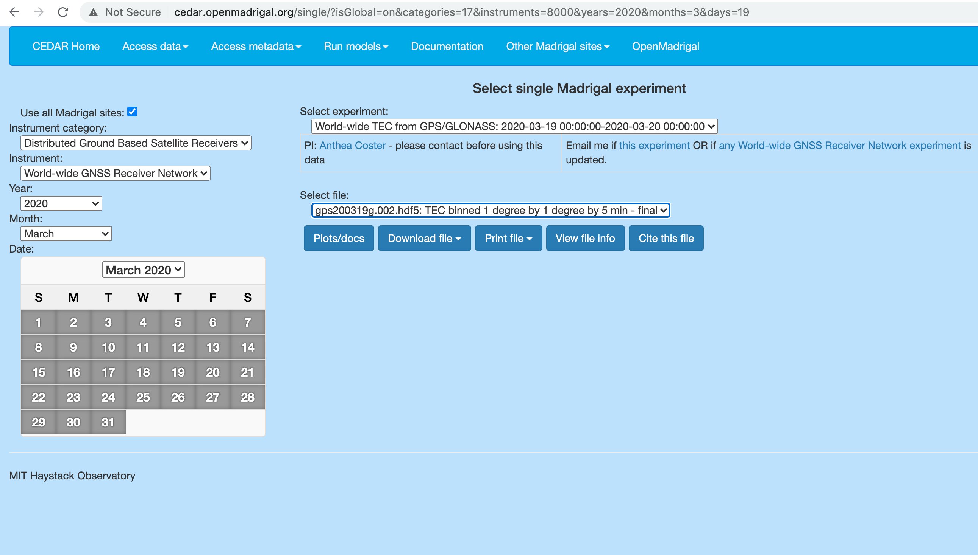

Try hitting Plots/docs

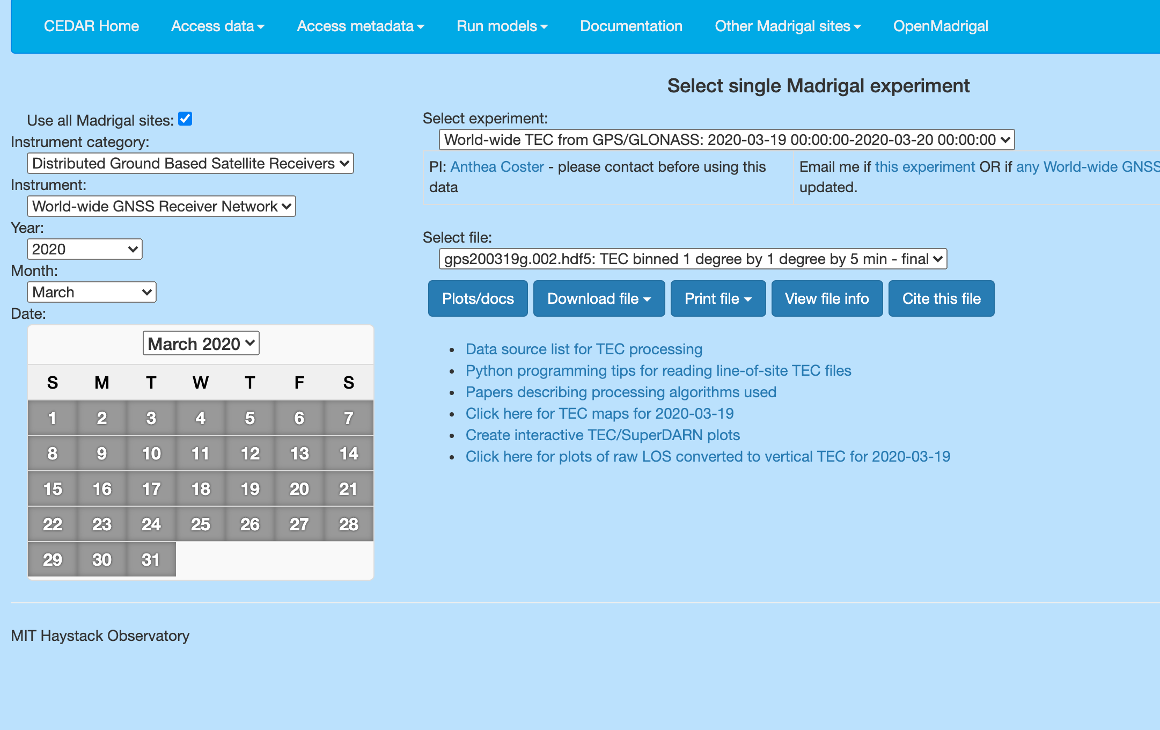

Try the click here for TEC maps for 2020-03-19.

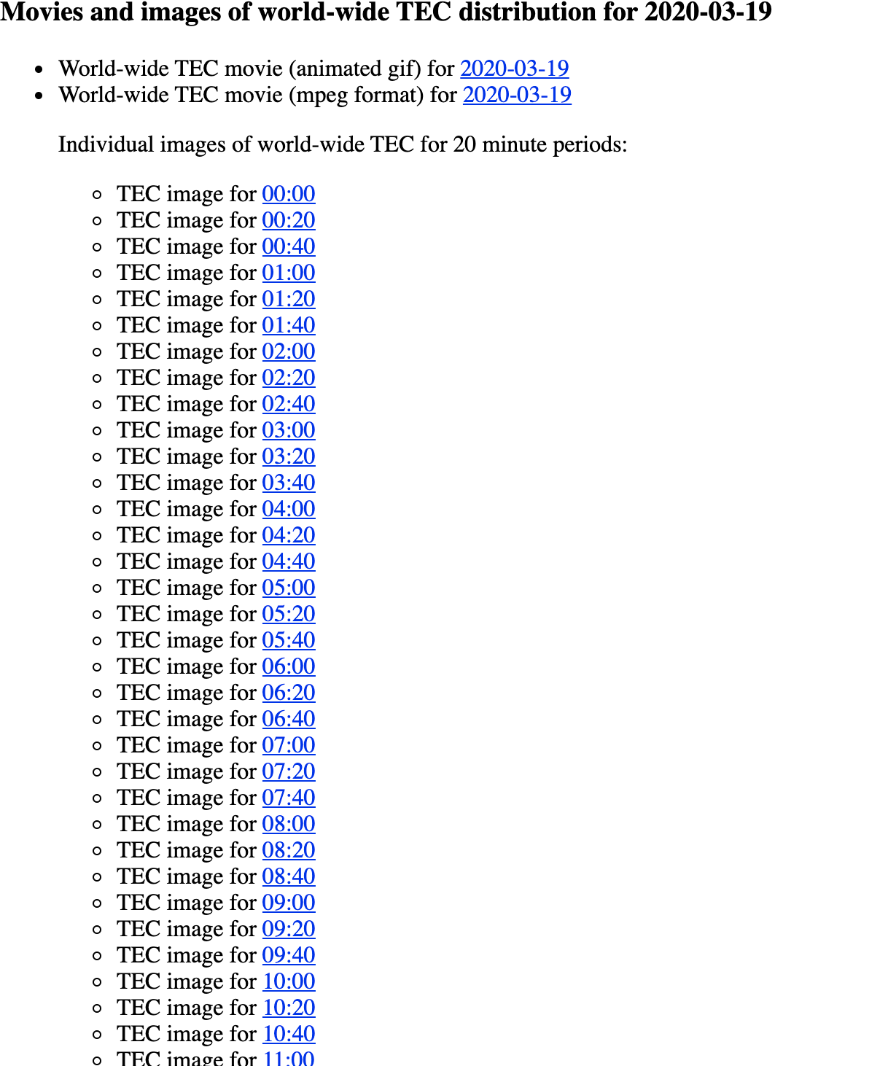

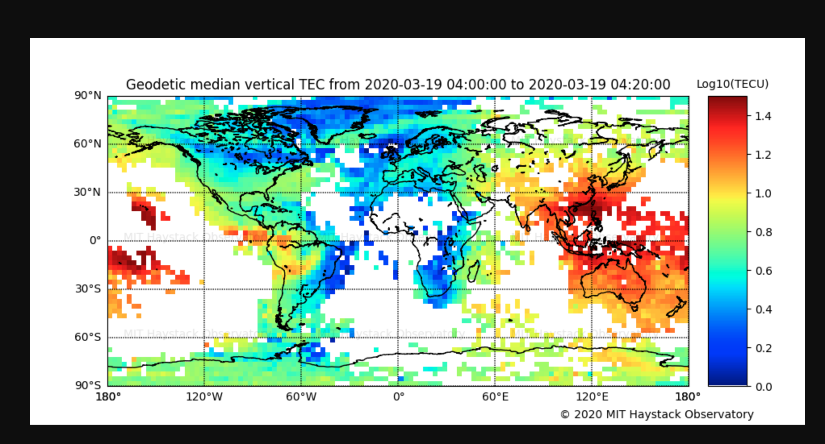

To download map,

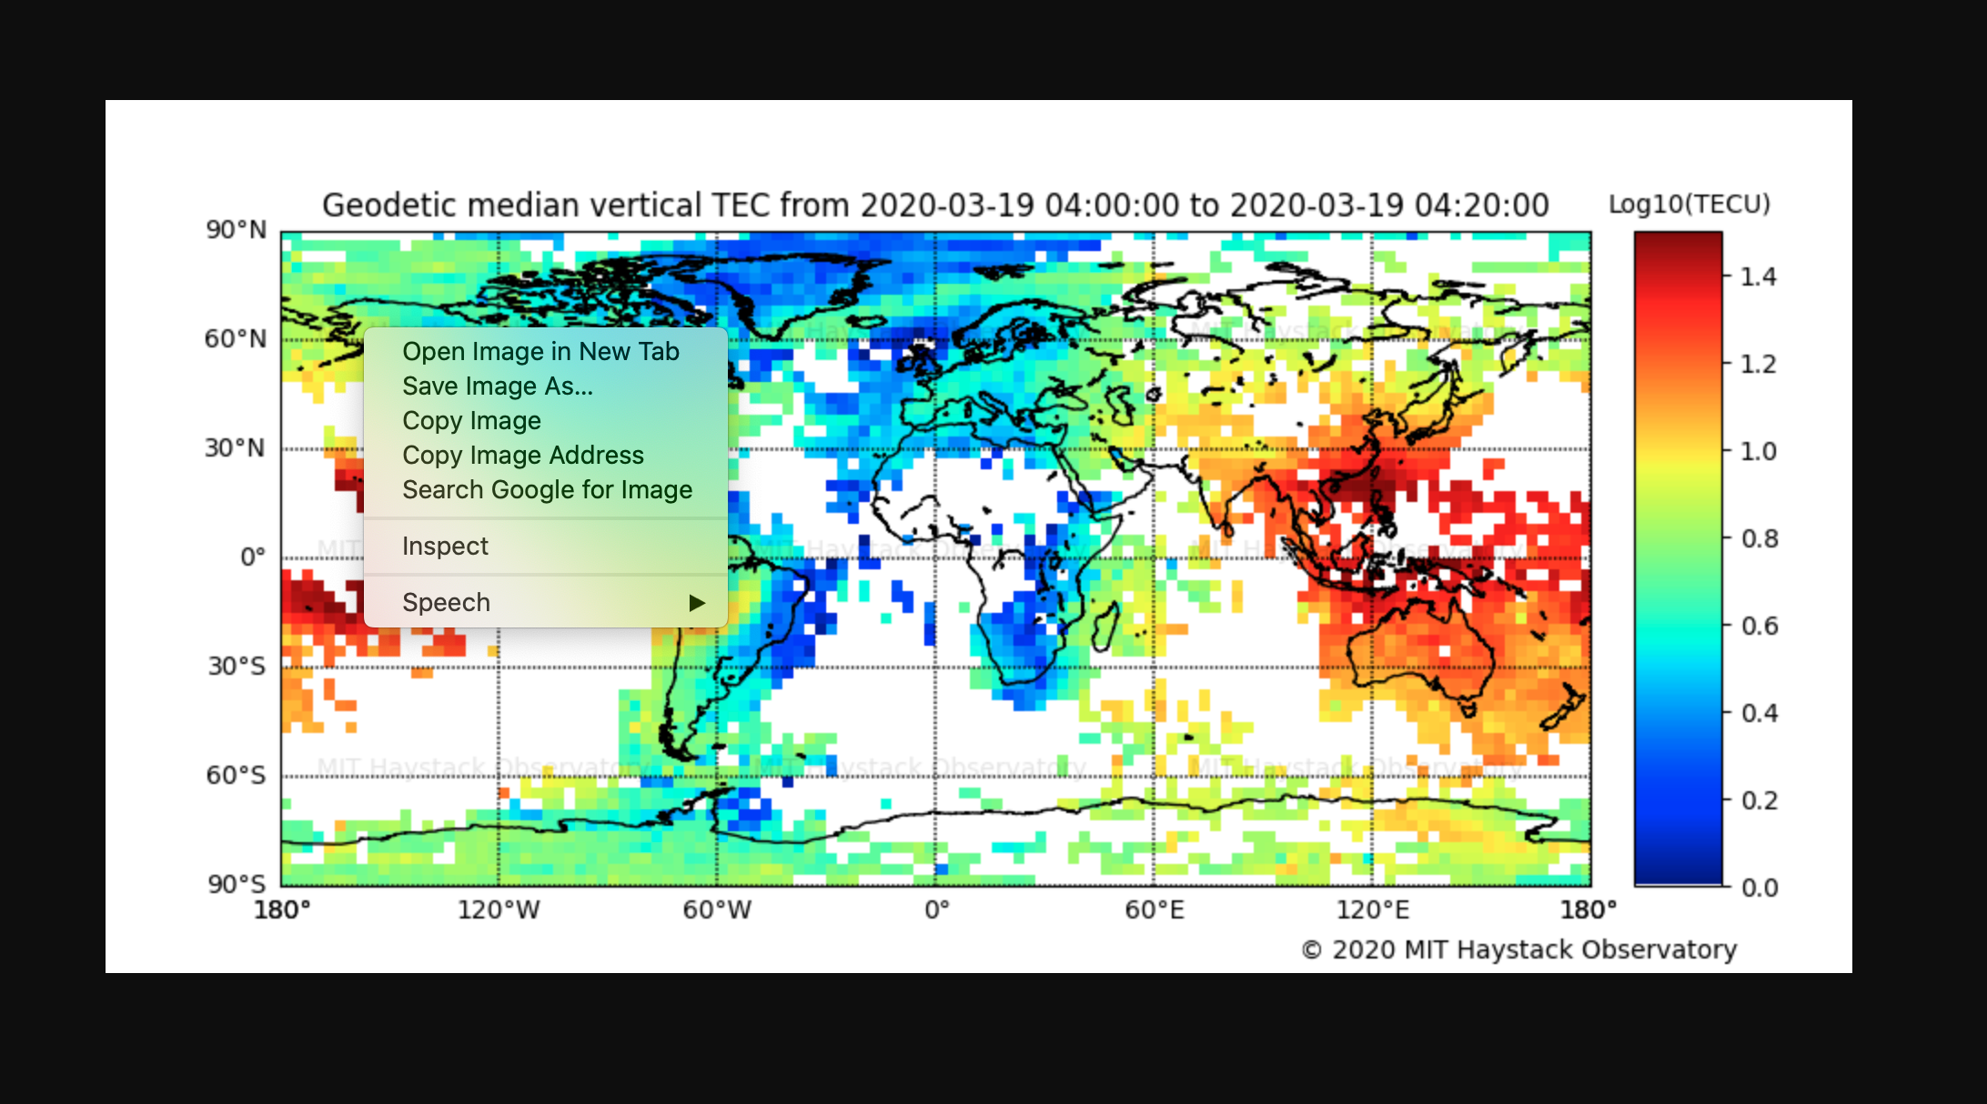

Hit cntrl shift enter to get above menu.

Publications making use of Madrigal GPS TEC data must include the following acknowledgment text. In addition, please contact the Haystack GPS PI, Anthea Coster, ajc at haystack.mit.edu, before submission.
GPS TEC data products and access through the Madrigal distributed data system are provided to the community by the Massachusetts Institute of Technology under support from US National Science Foundation grant AGS-1242204. Data for the TEC processing is provided from the following organizations: UNAVCO, Scripps Orbit and Permanent Array Center, Institut Geographique National, France, International GNSS Service, The Crustal Dynamics Data Information System (CDDIS), National Geodetic Survey, Instituto Brasileiro de Geografia e Estatística, RAMSAC CORS of Instituto Geográfico Nacional de la República Argentina, Arecibo Observatory, Low-Latitude Ionospheric Sensor Network (LISN), Topcon Positioning Systems, Inc., Canadian High Arctic Ionospheric Network, Institute of Geology and Geophysics, Chinese Academy of Sciences, China Meteorology Administration, Centro di Ricerche Sismologiche, Système d'Observation du Niveau des Eaux Littorales (SONEL), RENAG : REseau NAtional GPS permanent, GeoNet - the official source of geological hazard information for New Zealand, GNSS Reference Networks, Finnish Meteorological Institute, SWEPOS - Sweden, Hartebeesthoek Radio Astronomy Observatory, Crustal Dynamics Data Information System (CDDIS), Astronomical Institute of the University of Bern, TrigNet Web Application, South Africa, Australian Space Weather Services, RETE INTEGRATA NAZIONALE GPS, Estonian Land Board, and Virginia Tech Center for Space Science and Engineering Research.

