- FEMTOSECOND MAGNETO-OPTICS: PROBING ULTRAFAST MAGNETIZATION DYNAMICS
- FEMTOSECOND OPTO-MAGNETISM: CONTROLLING MAGNETISM BY LIGHT

Theo Rasing
Radboud University, Institute for Molecules and Materials, Nijmegen, the Netherlands
th.rasing@science.ru.nl

From the discovery of sub-picosecond demagnetization over a decade ago to the recent demonstration of magnetization reversal by a single 40 femtosecond laser pulse, the manipulation of spins by ultra short laser pulses has become a fundamentally challenging topic with a potentially high impact for future spintronics, data storage and manipulation and quantum computation. The realization that femtosecond laser induced all-optical switching (AOS) as observed in ferrimagnets exploits the exchange interaction between their sublattices, opens the way to engineer magnetic materials for AOS. Theoretically, this field is still in its infancy, using phenomenological descriptions of the none-equilibrium dynamics between electrons, spins and phonons. A proper description should include the time dependence of the exchange interaction and nucleation phenomena on the nanometer length scale. A practical challenge is how to bring the optical manipulation of magnetic media to the required nanoscale, which may be possible using plasmonic or wave-shaping techniques. An introduction to magneto-optics and opto-magnetism will be followed by a discussion of recent results and an outlook to probe and control magnetic order on the femtosecond time and nanometer length scale.

Recent references: 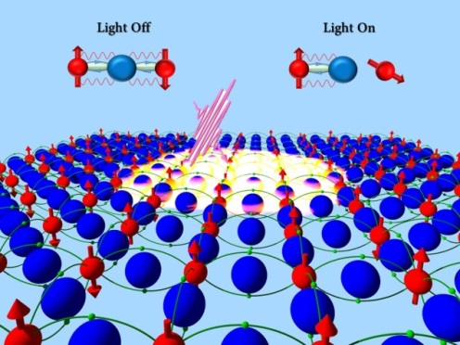
A. Kirilyuk, et al, Rev. Mod.Phys. 82, 2731-2784 (2010)
I. Radu et al, Nature 472, 205 (2011)
J. Mentink et al, Phys.Rev.Lett.108, 057202(2012)
T. Ostler et al, Nature Comm. 3, 666 (2012)
C. Graves et al, Nature Materials12, 293 (2013)
R. Evans et al, Appl.Phys.Lett., 2014
L. LeGuyader et al, Nature Comm. (2015)
I. Radu et al, Spin, (2015)
R. V. Mikhaylovskiy et al, Nature Comm. (2015)
Tian-Min Liu et al, Nano Letters, (2015)

